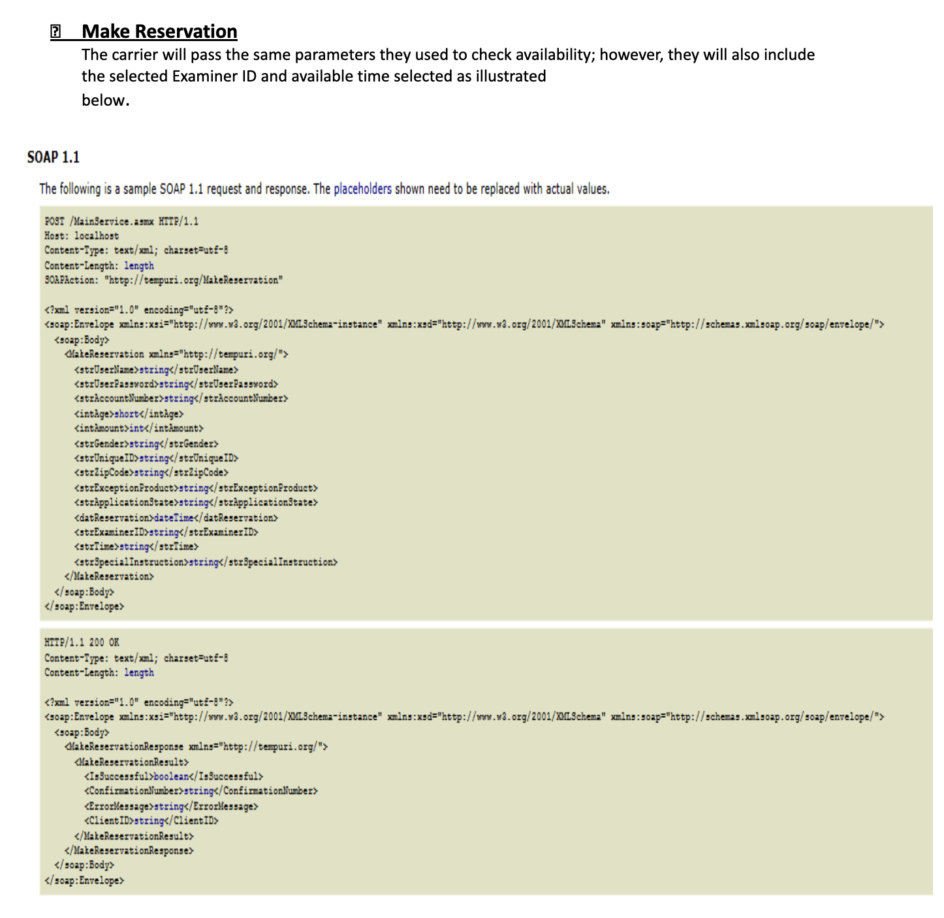
?
Make Reservation
The carrier will pass the same parameters they used to check availability; however, they will also include
the selected Examiner ID and available time selected as illustrated
below.
SOAP 1.1
The following is a sample SOAP 1.1 request and response. The placeholders shown need to be replaced with actual values.
POST /MainService.asmx HTTP/1.1
Host: localhost
Content-Type: text/xml; charset=utf-8
Content-Length: length
SOAPAction: "http://tempuri.org/MakeReservation"
<?xml version="1.0" encoding="utf-8"?>
<soap:Envelope xmlns:xsi="http://www.w3.org/2001/XMLSchema-instance" xmlns:xsd="http://www.w3.org/2001/XMLSchema" xmlns:soap="http://schemas.xmlsoap.org/soap/envelope/"> <soap:Body>
<MakeReservation xmlns="http://tempuri.org/">
<strUserName>string</strUserName> <strUserPassword>string</strUserPassword>
<strAccountNumber>string</strAccountNumber>
<intAge>short</intage>
<intAmount>int</intAmount>
<strGender>string</strGender>
<strUniqueID>string</strUniqueID>
<strZipCode>string</strZipCode>
<strExceptionProduct>string</strExceptionProduct>
<strApplicationState>string</strApplicationState>
<datReservation>dateTime</datReservation>
<strExaminerID>string</strExaminerID>
<strTime>string</strTime>
<strSpecial Instruction>string</strSpecial Instruction>
</MakeReservation>
</soap:Body>
</soap:Envelope>
HTTP/1.1 200 OK
Content-Type: text/xml; charset=utf-8
Content-Length: length
<?xml version="1.0" encoding="utf-8"?>
<soap:Envelope xmlns:xsi="http://www.w3.org/2001/XMLSchema-instance" xmlns:xsd="http://www.w3.org/2001/XMLSchema" xmlns:soap="http://schemas.xmlsoap.org/soap/envelope/"> <soap:Body>
<MakeReservationResponse xmlns="http://tempuri.org/">
<MakeReservationResult>
<IsSuccessful>boolean</IsSuccessful>
<ConfirmationNumber>string</ConfirmationNumber>
<ErrorMessage>string</ErrorMessage>
<ClientID>string</ClientID>
</MakeReservationResult>
</MakeReservationResponse>
</soap:Body>
</soap:Envelope>

